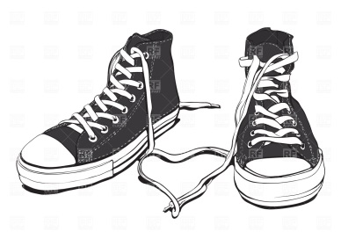
McU After School
Activity Club

GRADES KDG TO 4TH: TUESDAYS 3:00-4:30
GRADES 5TH TO 8TH: THURSDAYS 3:00-4:30
BEGINNING NOVEMBER 8
Join us after school on Tuesday or Thursday depending on your grade. Through the Dearborn Shines Healthy Initiative Grant, we will have a healthy after school snack, a short lesson on healthy living choices, fun activities, and walking/running. Questions? Email Mrs. Barker at barker@dearbornschools.org or give her a call: 827-1700
Please return this permissions slip to your Advisory teacher or classroom teacher by November 8, 2018. Be ready for fun and action!
Name of Student: Teacher/Advisory:
The undersigned Parent/Guardian understands that you give permission for your child named above to participate in the McU After School Activity Club. You also confirm that your child is not allergic to any food items. We will make an asserted effort to identify ingredients that may cause allergic reactions for those individuals with food allergies. Because of the number of different items/snacks served throughout the course of club, as well as the number of ingredients used, we cannot be guaranteed that every allergen in the food served will be identified and/or labeled. Consumers who are concerned with food allergies need to be aware of this risk. McU and Mrs. Barker cannot assume any liability for adverse reactions to food consumed or items one may come in contact with while eating. You also consent to release the Physical Activity Leader (Mrs. Barker) and her assistants harmless from all actions, claims, liability, and expenses, whether known or unknown, present or future (and expressly including {1} actions brought or claims made by the student above after reaching the age of majority, and {2} actions or claims for damages caused in whole or in part by the negligence or gross negligence of the indemnities) relating to or arising from or connected in any many with the student’s participation in the McU After School Activity Club.
Parent/Legal Guardian’s Name: Phone:
Signature: Date:
Relationship to Participant: Food Allergies:

